# GUJARAT TECHNOLOGICAL UNIVERSITY

### Chandkheda, Ahmedabad Affiliated

**D.A DEGREE COLLEGE OF ENGINEERING & TECHNOLOGY**

Presented Project Report on

**“STOCK PRICE PREDICTION USING MACHINE LEARNING”**

Under subject of

**DESIGN ENGINEERING II-A (3150001)**

B.E. SEMESTER- V

|  |  |  |
| --- | --- | --- |
|  | SUBMITTED BY |  |
| **Sr. No.** | **Name of Student** | **Enrollment No.** |
| 1. | KAKADIYA JAY | 181180107018 |
| 2. | PATEL KINJAL | 181180107031 |
| 3. | PATEL SAGAR | 181180107033 |
| 4. | RANA NUPUR | 181180107042 |

**GUIDED BY:**

**Prof. Asim Makkad**

Head of Department

**Academic year** (2020-2021)

**D.A DEGREE ENGINEERING &TECHNOLOGY**



**CERTIFICATE**

This is to certify that the **KAKADIYA JAYKUMAR A, (181180107018)** of Semester 5th , **Department of Computer Engineering** has satisfactorily completed the work under the **“STOCK PRICE PREDICTION USING MACHINE LEARNING”** in **Design Engineering II A (3150001)** course.

|  |  |
| --- | --- |
| **INTERNAL GUIDE** | **HEAD OF DEPARTMENT** |
| PROF. ASIM MAKKAD | PROF. ASIM MAKKAD |
| ASSISTANT PROFESSOR | ASSISTANT PROFESSOR |
| COMPUTER DEPARTMENT | COMPUTER DEPARTMENT |
|  |  |

**D.A DEGREE ENGINEERING &TECHNOLOGY**



**CERTIFICATE**

This is to certify that the **PATEL KINJALBEN G, (181180107031)** of Semester 5th , **Department of Computer Engineering** has satisfactorily completed the work under the **“STOCK PRICE PREDICTION USING MACHINE LEARNING”** in **Design Engineering II A (3150001)** course.

|  |  |
| --- | --- |
| **INTERNAL GUIDE** | **HEAD OF DEPARTMENT** |
| PROF. ASIM MAKKAD | PROF. ASIM MAKKAD |
| ASSISTANT PROFESSOR | ASSISTANT PROFESSOR |
| COMPUTER DEPARTMENT | COMPUTER DEPARTMENT |
|  |  |

**D.A DEGREE ENGINEERING &TECHNOLOGY**



**CERTIFICATE**

This is to certify that the **PATEL SAGAR B, (181180107033)** of Semester 5th , **Department of Computer Engineering** has satisfactorily completed the work under the **“STOCK PRICE PREDICTION USING MACHINE LEARNING”** in **Design Engineering II A (3150001)** course.

.

|  |  |
| --- | --- |
| **INTERNAL GUIDE** | **HEAD OF DEPARTMENT** |
| PROF. ASIM MAKKAD | PROF. ASIM MAKKAD |
| ASSISTANT PROFESSOR | ASSISTANT PROFESSOR |
| COMPUTER DEPARTMENT | COMPUTER DEPARTMENT |

**D.A DEGREE ENGINEERING &TECHNOLOGY**



**CERTIFICATE**

This is to certify that the **RANA NUPUR P, (181180107042)** of Semester 5th , **Department of Computer Engineering** has satisfactorily completed the work under the **“STOCK PRICE PREDICTION USING MACHINE LEARNING”** in **Design Engineering II A (3150001)** course.

|  |  |
| --- | --- |
| **INTERNAL GUIDE** | **HEAD OF DEPARTMENT** |
| PROF. ASIM MAKKAD | PROF. ASIM MAKKAD |
| ASSISTANT PROFESSOR | ASSISTANT PROFESSOR |
| COMPUTER DEPARTMENT | COMPUTER DEPARTMENT |

### D.A DEGREE ENGINEERING &TECHNOLOGY

BE – 5ThSemester

Design Engineering II - A (3150001)

**INDEX**

|  |  |  |
| --- | --- | --- |
| **SR.NO** | **CONTENT** | **Page no.** |
| 1) | INTRODUCTION | 01 |
| 1.1 Design Thinking | 01 |
| 2) | AEIOU SHEET | 02 |
| 3) | EMPATHY MAPPING | 05 |
| 4) | IDEATION CANVAS | 08 |
| 5) | PRODUCT DEVELOPMENT CANVAS | 10 |
| 6) | LEARNING NEED MATRIX | 13 |
| 7) | MIND MAPPING | 15 |
| 8) | PROTOTYPE | 16 |
| 9) | CONCLUSION | 17 |

* + - 1. **INTRODUCTION**

Stock Price Prediction is a web-app which not only shows a real-time rates of a specific or all listed stocks but also Predict future trends to earn more. To Provide an accurate information to customer and the Refresh rate as per the yahoo and google finance, it is developed using the official stock market (Financial)APIs. So, it’s a perfect app for New commers as well as existing investers.

### DESIGN THINKING

Design thinking is a process which includes the “building up” of ideas, with few, or no, limits on breadth during a “brainstorming” phase. This helps reduce fear of failure in the participants and encourages input and participation from a wide variety of sources in ideation phase. The phrase thinking outside the box has been coined to describe one goal of brain storming phase and is encouraged, since this aid in the discovery of hidden elements and ambiguities in the situation and discovering potentially faultyassumptions.

Although design is always influenced by individual preferences, the design thinking methods shares a common set of traits, mainly: creativity, ambidextrous thinking, team work, user centeredness (empathy ), curiosity and optimism. In design thinking is a formal method for practical, creative resolution of problems and creation of solutions, with the intent of an improved future result. In this regard it is a form of solution based or solution-focused thinking **-** starting with a goal (a better future situation ) instead of solving a specific problem. By considering both present and future conditions and parameters of the problem, alternative solutions may be explored simultaneously. This type of thinking most often happens in the built, or artificial,environment.

# AEIOUSUMMARY

**A: Activities**

**E: Environment**

**I : Interactions**

**O: Objects**

**U: Users**

This canvas is totally based on the observation.After observing some documents like yahoo finance & google finance we have started working to make itfair.

### Activities

The activities related with the user are included in this section. Some of those activities are:

→SIGN UP

→VERIFICATION

→STOCK ANALAYSIS

→ HELP TO DIGITALIZATION

* **Environment**

This sheet includes the environmental behavior all around the user.

→NATURAL ISSUES

→CROWED

→WEATHER PROBLEM

* **Interaction**

**  **→ CUSTOMERS TO COMPANY

→ STAKEHOLDER TO COMPANY

→ COMPANY MEMBERS TO COMPANY

### Objects

→ TIME SAVING

→SUPPORT DIGITALIZATION

→ ADVANCE TECHNOLOGY

### Users

The users of this project are all people.

→EMPLOYEES

→CUSTOMER

→ STAKEHOLDER

→AGENTS

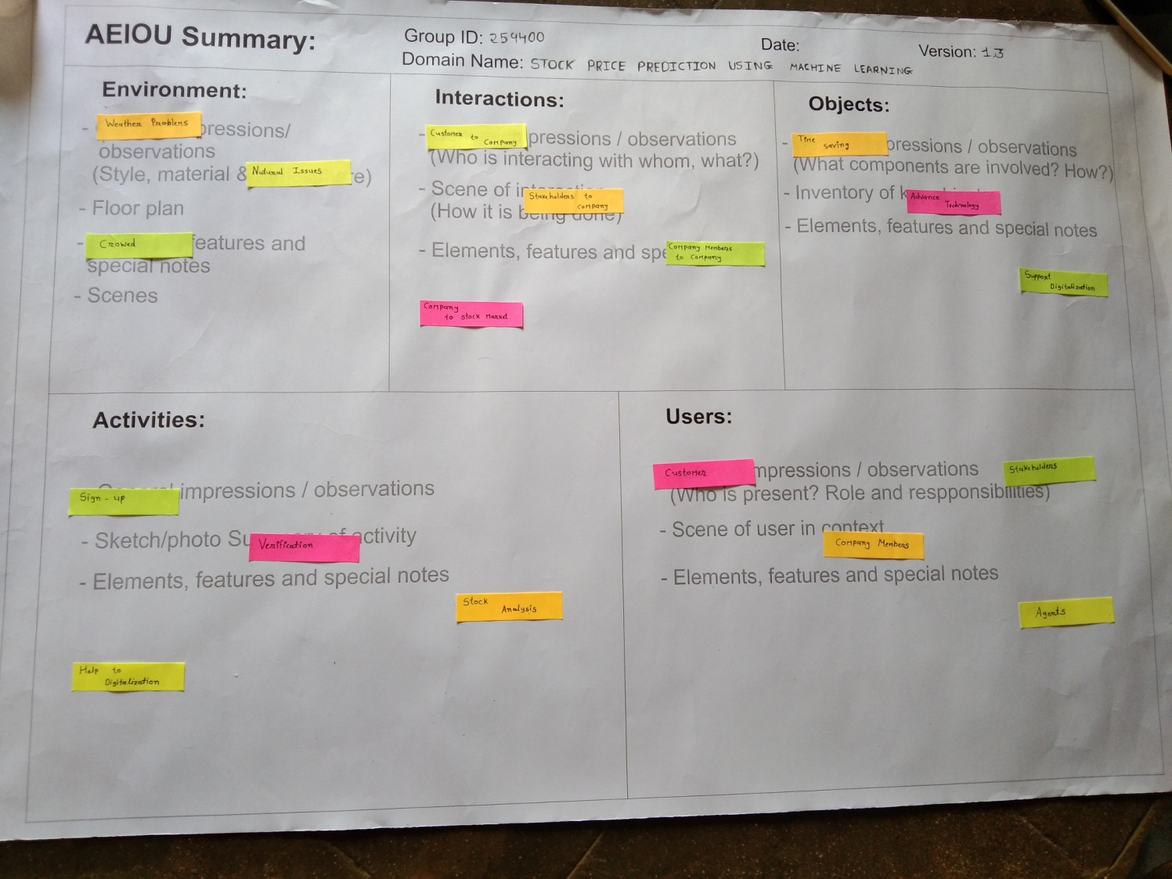

# EMPATHYMAPPING

Empathy is the experience of understanding another person’s condition from their perspective.

One of the most prominent use cases of machine learning is “Fintech” (Financial Technology for those who aren't buzz-word aficionados); a large subset of which is in the stock market. Financial theorists, and data scientists for the better part of the last 50 years, have been employed to make sense of the marketplace in order to increase return on investment. However, due to the multidimensional nature of the problem, the scale of the system, and inherent variation with time, it has been an overwhelmingly tough challenge for humans to solve, even with the assistance of conventional data analytics tools. However, with the onset of recent advancements in machine learning applications, the field has been evolving to utilize non-deterministic solutions the “learn” what is going on in order to make more accurate predictions.

Here we would like to explain the aspects of this canvas by our project.

### Users

→ Employee

→ Stakeholders

→ Customer

→ Broker

### StakeHolders

→Government

→ Company Owner

→Company Members

* **STORY BOARDING:**

### Happy story:

### 1st happy story

Our Web-App provide technical analysis visualization and prediction using stock market data. It is helpful to Investors, stockholders etc.

### 2nd happy story

### The Investor will get know comparatively analyze the effectiveness prediction of stock market, which helps to invest in right stock and gives maximum profit.

### Sad story :

* **1st sad story**

When investing in the stock market, the higher the return the grater the risk of losing money.

* **2nd sad story**

Many investors losses their Money because of this pandemic.

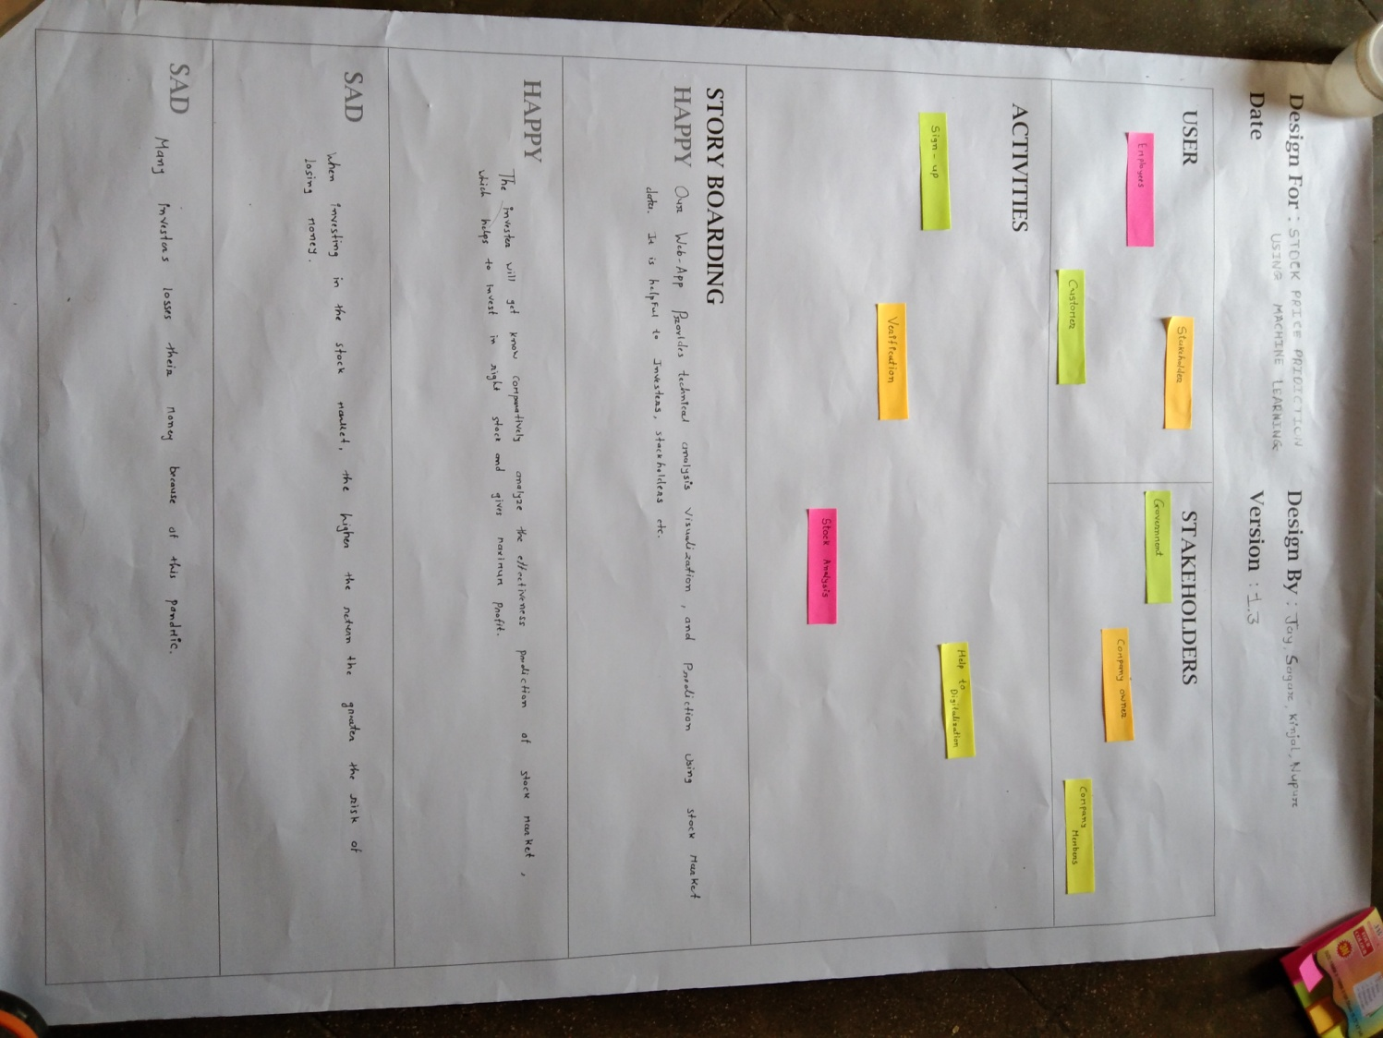

**4.Ideation Canvas**

* **The general activities**

→ Sign Up

→ Online process

→ verify Account

→ Web-Application

* **Situation / Context / Location**

→ weather problem

→ In crowdy environment

→ help in digitalization

* **Props / Possible Solutions:**

→ Tablet

→ Android / IOS

→ Computer

→ Mobile

→ Application

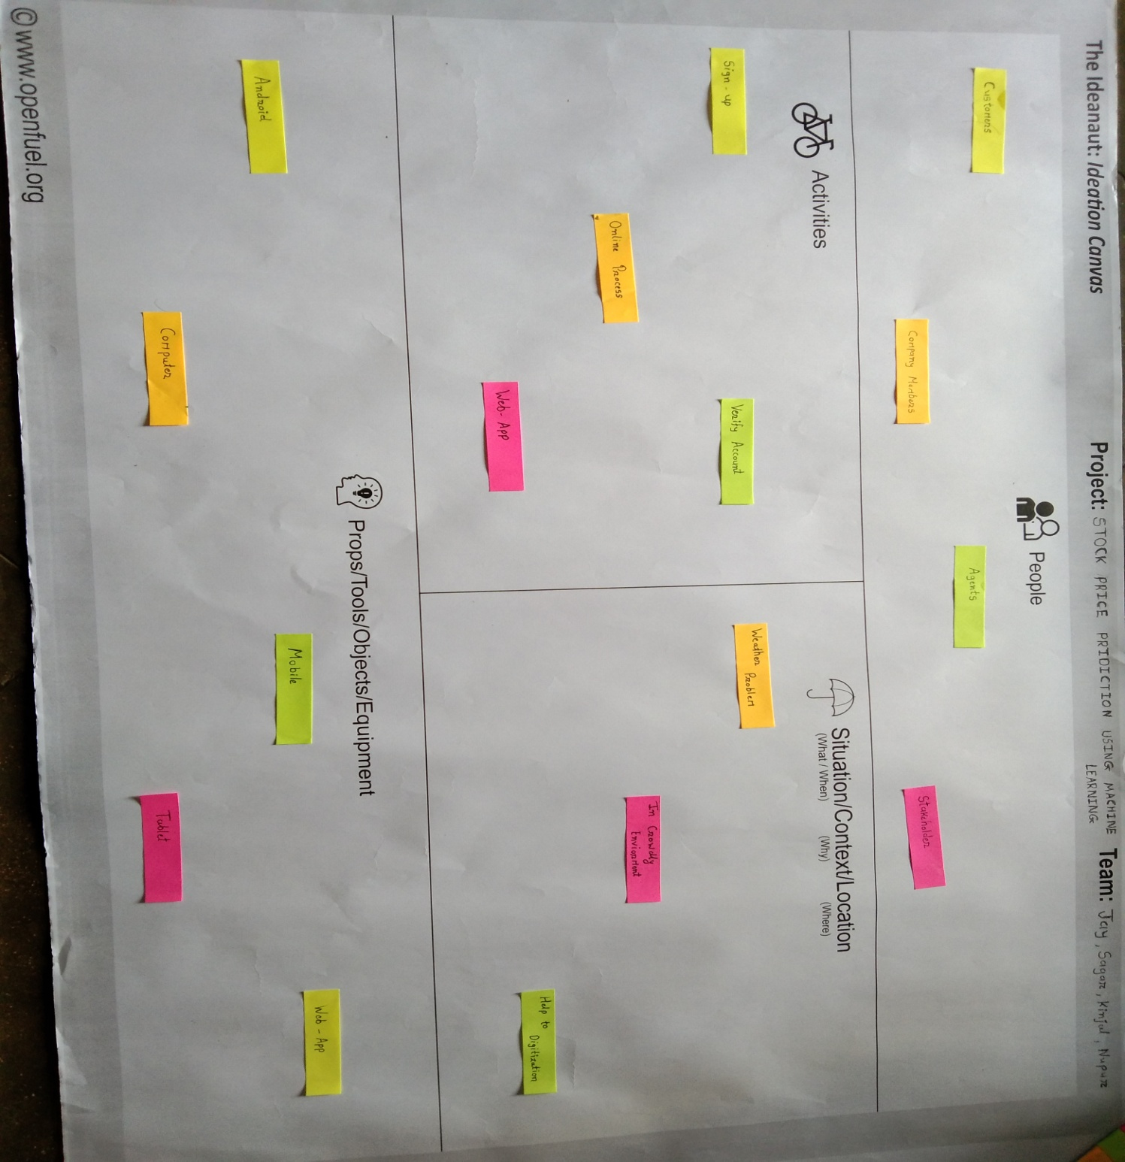

**5.PRODUCT DEVELOPMENT CANVAS**

* **Purpose**

→ Easy to modify

→ Time saving

→ useful for workers and students

* **People**

→ Customers

→ Employee

→Stakeholder

* **Components**

→ Computer

→ Wi-fi

→ Android

→ Application

* **Features**

→ Safety

→ Easy to Understand

* **Product Function**

→ fast solution

→ Multitasking

→ Stake Price Predict

* **Product Experience**

→ Comfortable

→ Easy to Acess

* **Customer Revalidation**

→ Otp verification

→ Security validation

* **Reject, Redesign, And Retain**

→ More secure

→ Make quick response

→ website also created using API

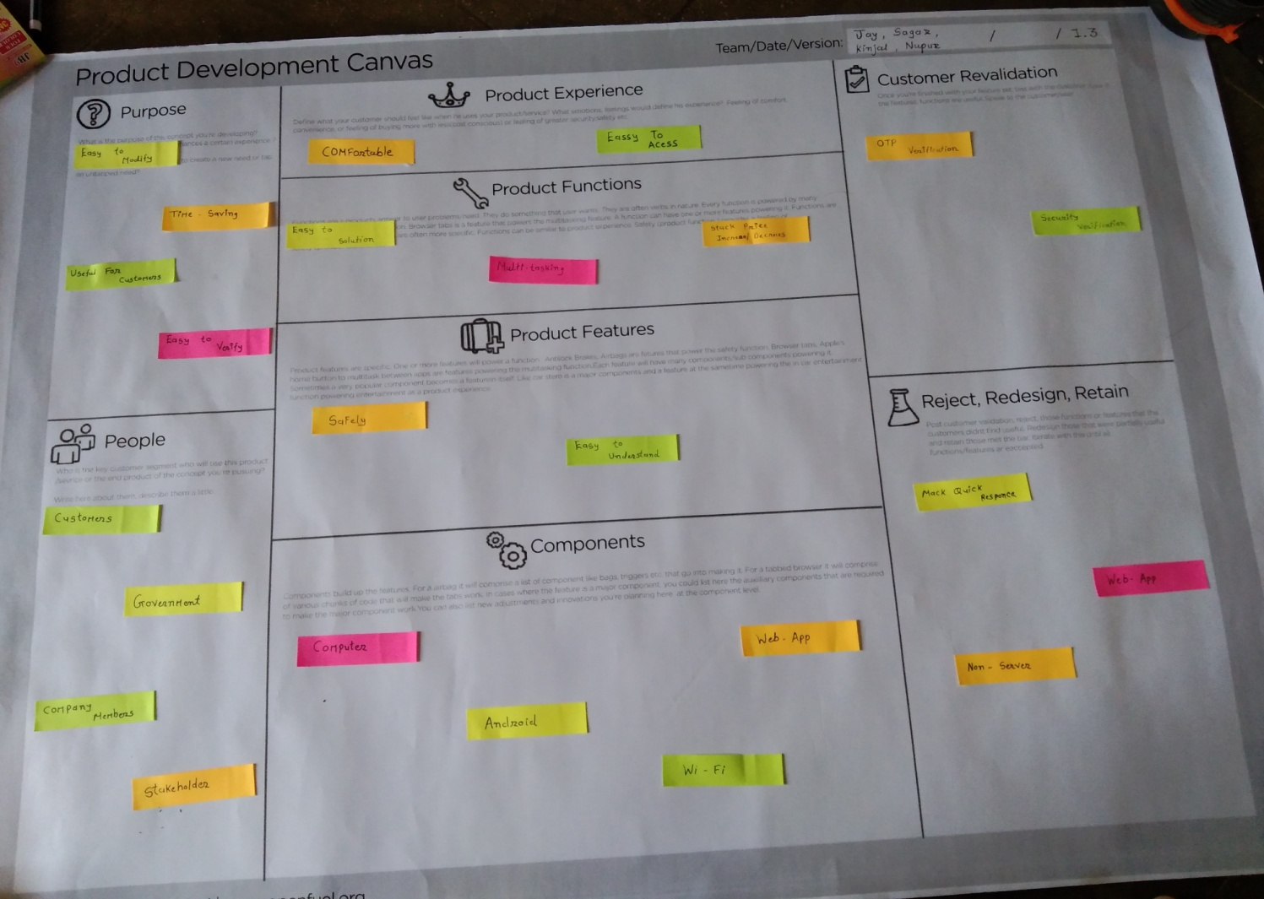

**6.LEARNING NEED MATRIX**

* **6.1 Domain of skill sets to belearned:**

→ STOCK PRICE PREDICTION USING MACHINE LEARNING

# 6.2During BE 2/Stage1:

### 1)Application ProcessInvolved/Methods:

→PYTHON

→ANDROID

→MACHINE LEARNING

→JAVA-SCRIPT

**2)Applicable Standards And DesignSpecification:**

→ Android apps can be written using kotlin and JAVA language.

→ Python is concerent,class based object oriented programming language.

**3)Component materials & strengthcriterea:**

→OS

→Mobile

→Internet

→Server

**4)Software/Tools:**

→ Pycharm

→ Jupyter Notebook

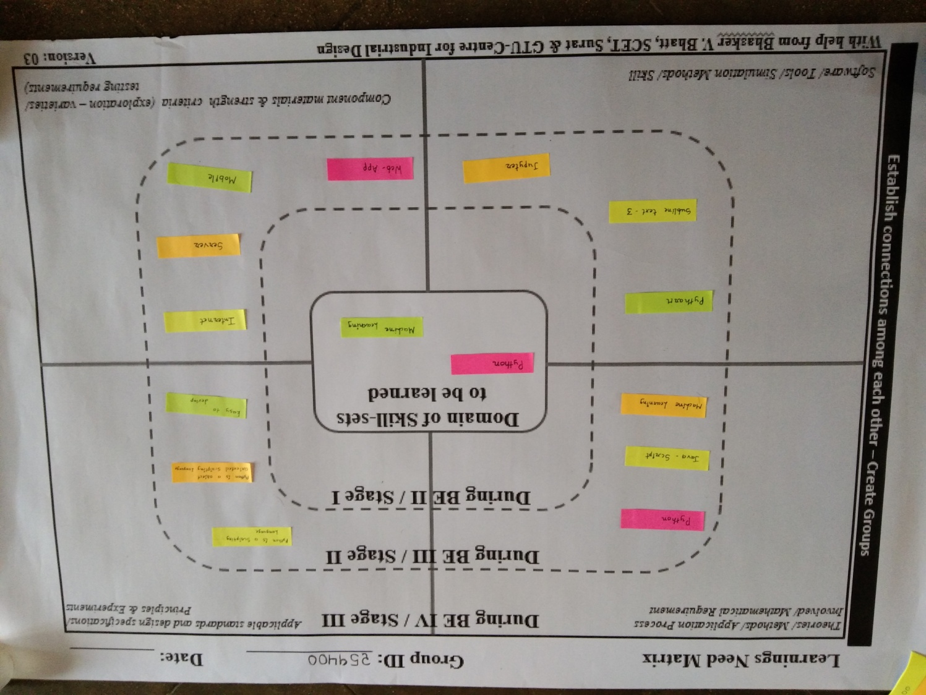

# 7.MINDMAPPING

### C:\Users\jayka\Downloads\IMG_20201205_122326.jpg

**8.PROTOTYPE**

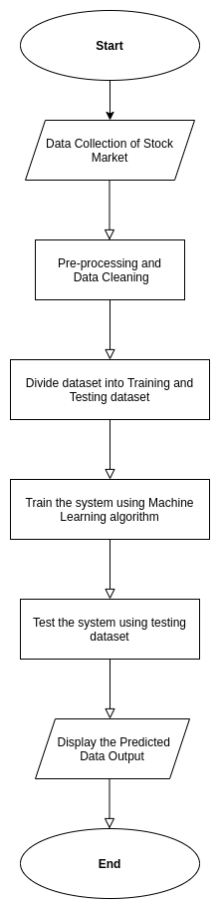

# 9..CONCLUSION

Models have what are known as “hyperparameters.” These are the parameters that govern the model, they define how the model is created. Altering these can give us better (or perhaps worse) results. Examples include: number of neurons in each hidden layer, the number of hidden layers, the activation function, etc. Our goal here is to “tune” these hyperparameters to achieve a lower error tolerance than was possible with our first model. The simplest way to do this, in my opinion, is do increase the number of neurons in the hidden layers. I am by no means a leading source of knowledge on this topic, but I will venture far enough to say that increasing the number of neurons and/or the number of hidden layers increases the level of abstraction with which the model can represent the given data.

# -:References:-

## →[www.nptel.com](http://www.nptel.com/)

→[www.darshanstudymaterial.com](http://www.darshanstudymaterial.com/)

→[www.gtustudymeterial.com](http://www.gtustudymeterial.com/)

→www.data-flair.training

**\*THE END\***